**IBM ASSIGNMENT 1:**

1.Write a python program to test a given number is prime or not.

**PROGRAM**

num=int(input("enter a number:"))

for x in range(2,num):

if num%x==0:

print("{} is not a prime number".format(num))

break

else:

print("{} is a prime number".format(num))

**OUTPUT**

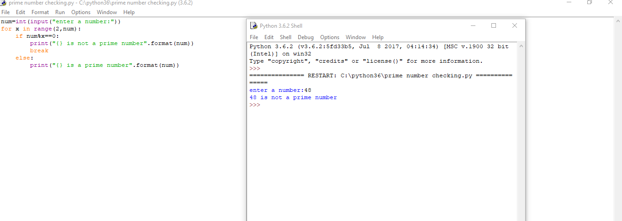

2.Write a python program to display prime number series up to given numbers

**PROGRAM**

first=int(input("enter first number"))

last=int(input("enter last number"))

for n in range(first,last+1):

if n > 1:

for i in range(2,n):

if(n%i)==0:

break

else:

print(n)

**OUTPUT**

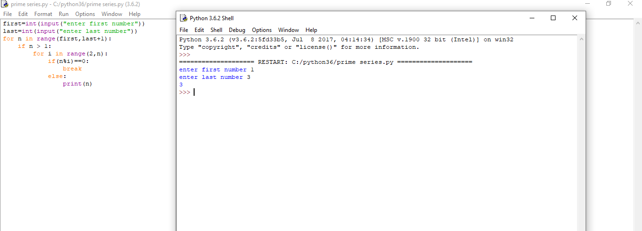

3.Write a python program to generate Fibonacci series

**PROGRAM**

n = int(input("\nPlease Enter the Range : "))

i = 0

First_Value = 0

Second_Value = 1

while(i < n):

if(i <= 1):

Next = i

else:

Next = First_Value + Second_Value

First_Value = Second_Value

Second_Value = Next

print(Next)

i = i + 1

**OUTPUT**

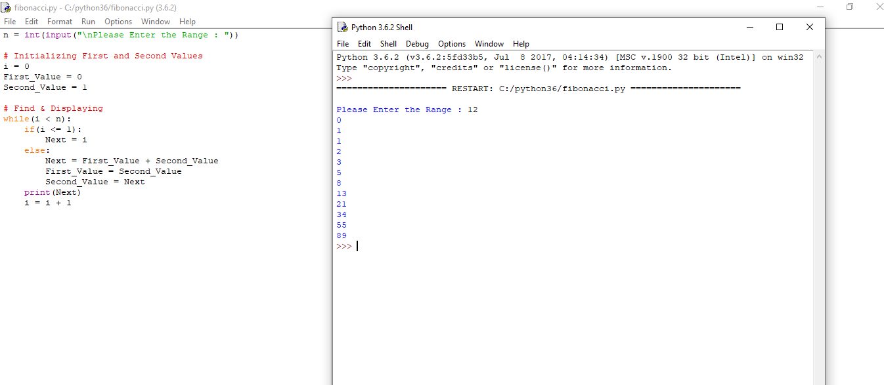

4.Write a program to generate odd numbers from m to n using while loop

**PROGRAM**

maximum = int(input(" Please Enter the Maximum Value : "))

number = 1

while number <= maximum:

if(number % 2 != 0):

print("{0}".format(number))

number = number + 1

**OUTPUT**

